Technology Stack (Architecture & Stack)

Date | 27 September 2026
Team ID | SWTID-2026-5541
Project Name | FitTrack
Maximum Marks | 4 Marks

Technical Architecture
User → User Interface → Backend/API → AI/ML Module → Database → Personalized Results

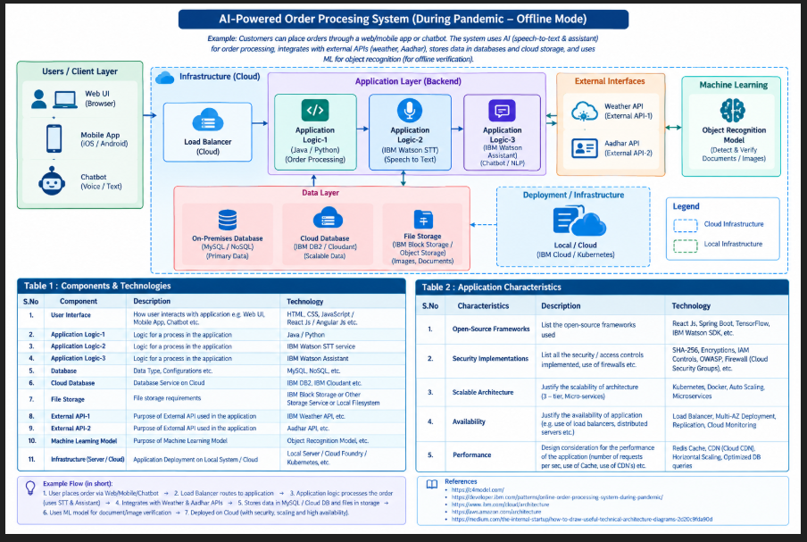

Table 1: Components & Technologies
S.No | Component | Description | Technology
1 | User Interface | Interface through which users register, enter fitness details, track activities and view recommendations | HTML, CSS, JavaScript
2 | Application Logic-1 | Handles user registration, login and fitness data processing | Python
3 | Application Logic-2 | Processes fitness information and generates personalized recommendations | Python
4 | Application Logic-3 | Connects the frontend with backend and AI services | REST API
5 | Database | Stores user details, fitness data, activity records and progress | MySQL
6 | Cloud Database | Stores application data on cloud infrastructure | Cloud Database
7 | File Storage | Stores required user files and application resources | Local File System / Cloud Storage
8 | External API | Provides external fitness-related services or information when required | REST API
9 | Machine Learning Model | Analyses fitness/activity data and provides personalized recommendations | AI/ML Model
10 | Infrastructure | Hosts and runs the application | Local Server / Cloud
11 | Backend API | Provides communication between frontend, database and AI module | Python Flask / FastAPI

Table 2: Application Characteristics
S.No | Characteristics | Description | Technology
1 | Open-Source Frameworks | Frameworks used for developing the application | Python, Flask/FastAPI
2 | Security Implementations | Provides authentication and protection of user information | Password Hashing, Authentication, HTTPS
3 | Scalable Architecture | Separates user interface, application logic and database for easier expansion | 3-Tier Architecture
4 | Availability | Application can be deployed on a server or cloud for continuous access | Cloud Deployment
5 | Performance | Optimized API communication and database operations improve application response time | REST API, Database Optimization

Application Workflow
- User registers and logs into AI Fit Track.
- User enters fitness and activity details.
- The frontend sends the information to the backend through an API.
- The backend validates and processes the data.
- The AI/ML module analyses the fitness information.
- Personalized fitness recommendations are generated.
- User information and progress are stored in the database.
- The processed results are sent back to the frontend.
- User can view recommendations and monitor fitness progress.

Technology Stack
Frontend: HTML, CSS, JavaScript
Backend: Python
API: REST API
Database: MySQL
AI/ML: Machine Learning / AI Model
File Storage: Local File System / Cloud Storage
Infrastructure: Local Server / Cloud
Architecture: 3-Tier Architecture
Security: Authentication, Password Hashing, HTTPS

